***Secured Pizza Ordering System(POS)***

**A Project Report for Industrial Training**

###### ***Submitted by***

**Ankur Kushyap**

**Avishek Majhi**

**Chetan Kumar**

**Prakash Kumar**

**Taha Kasim Saifee**

***In the fulfillment for the award of the degree of***

##### **BCA**

in

Computer Applications

**The Calcutta Anglo Gujarati College**

At

**Ardent Computech Pvt. Ltd.**



**October - November 2015**



**CERTIFICATE FROM SUPERVISOR**

This is to certify that Mr. Ankur Kasyap, Mr.Avishek Majhi, Mr.Chetan Kumar,Mr.Prakash Kumar and Mr.Taha Kasim Saifee successfully completed the project titled **"Pizza Ordering System**" under my supervision during the period from October to November which is in partial fulfillment of requirements for the award of the Bachelor of Computer Applications and submitted to BCA Department of The Calcutta Anglo Gujarati College, Kolkata.

*Signature and Seal of the Supervisor*

**Date:**  **Name & Designation**

**Project Supervisor**

**Acknowledgement**

I take this opportunity to express my deep gratitude and sincerest thanks to my project mentor, for giving most valuable suggestion, helpful guidance and encouragement in the execution of this project work.

I would like to give a special recognition to my colleagues. Last but not the least I am grateful to all the faculty members of Ardent Computech Pvt. Ltd. and their support.

|  |  |
| --- | --- |
| **Table of Contents** | **Page No** |
| 1. Abstract | 6 |
| 1. Introduction | 6 |
| 2.1 Relevance of the Topic | 6 |
| 2.2 Problem Definition | 6 |
| 2.3 Project Objective | 6 |
| 1. Methodology | 7-8 |
| 1. System Analysis | 8-15 |
| 4.1 Feasibility | 8-10 |
| 4.2 Existing System | 10 |
| 4.3 Proposed System | 11 |
| 4.4 Data Flow Diagram | 11-12 |
| 4.5 Use Case Diagram | 13-15 |
| 4.6 Software Requirements | 15 |
| 4.6.1 Front End | 15 |
| 4.6.2 Middle End | 15 |
| 4.6.3 Application Server | 15 |
| 4.6.4 Database Server | 15 |
| 4.6.7 Hardware Requirements | 15 |
| 1. System Design | 16-22 |
| 5.1 Database Design | 16-17 |
| 5.1.1 ER Diagram | 16 |
| 5.1.2 Normalization | 17 |
| 5.2 Table Design | 17-19 |
| 5.2.1 Table Definition | 17-19 |
| 5.3 Form Design | 20 |
| 5.3.1 Components of Form | 20 |
| 5.4 Home Page | 20 |
| 5.5 Links and Web Pages | 21-22 |
| 1. Coding | 22 |
| 6.1 Features of Coding | 23 |
| * 1. Coding | 23 |
| 7. Testing | 24 |
| 8. Experimental Results | 30 |
| 9. Contribution of the Work | 30 |
| 10. Future Scope | 30 |
| 11. Conclusion | 30 |
| 12. Bibliography |  |

**List of Tables:**

|  |  |  |  |
| --- | --- | --- | --- |
| ***Serial No*** | ***Table Name*** | ***Sections*** | ***Page*** |

**1 Category 5.2.1 17**

**2 User profile Table 5.2.1 17**

**3 Food Table 5.2.1 17-18**

**4 Order Table 5.2.1 18**

**5 Inventory Table 5.2.1 18**

**List of Figures:**

|  |  |  |  |
| --- | --- | --- | --- |
| ***Serial No*** | ***Figure Name*** | ***Sections*** | ***Page*** |

**1 DFD-Level 0 4.4 11**

**2 DFD-Level 1 4.4 12**

**3 Use Case Diagram for Admin 4.5 13**

**4 Use Case Diagram for Customer 4.5 13**

**5 ER Diagram 5.1 16**

1. **Abstract**

The project planned to automate "Pizza Ordering System" is a Web application intended to be used by user for ordering of pizza. The ordering mechanism is fairly easy as the system becomes computerized.

1. **Introduction**
   1. **Relevance of the Topic**

The project is very much relevant in today’s world. Customers can very easily

order pizza through the web portal.

* 1. **Problem Definition**

The project Pizza Ordering System is surely going to make ordering of

pizza a lot easier. Users can now order pizza from the comforts of their

home.

* 1. **Project Objective**
* To provide online ordering facilities
* Support services in an integrated fashion so as to provide a simple and hassle free ordering platform.

The system interacts to the users (customer, admin) by means of some front-end **form**. To enter the system a **signin form** will appear where **userID**and **Password** for both Admins and for the Customers will have to be entered to log into the system and then this will check the **Type** of that user. According to type the System is loaded.

After signin, customers enters into their profile. Customer can check the pizza menu and order it.

After signin,admin can enter into its profile. Admin can view the Food list, Order List and Store List.Admin can also update/modify/add the details of Pizza and Store. New users must have to register before signin. Every stage data is stored in the database. This is why the system is very easy to use and every user can accept the system by thinking its utility in present and by applying the idea of Prototyping Model the system can be developed with more features in future.

**3. Methodology**

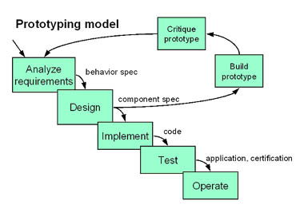

The prototyping paradigm begins with **requirements gathering**. Developer and customer meet and define the overall objectives for the software, identify whatever requirements are known, and outline areas where further definition is mandatory. A **"quick design"** then occurs. The quick design focuses on a representation of those aspects of the software that will be visible to the customer/user (e.g., input approaches and output formats). The quick design leads to the construction of a prototype. The prototype is evaluated by the customer/user and used to refine requirements for the software to be developed. Iteration occurs as the prototype is tuned to satisfy the needs of the customer, while at the same time enabling the developer to better understand what needs to be done.

Ideally, the prototype serves as a mechanism for identifying software requirements. If a working prototype is built, the developer attempts to use existing program fragments or applies tools (e.g., report generators, window managers) that enable working programs to be generated quickly.

**4. System Analysis**

* 1. **Feasibility Study**

An important outcome of preliminary investigation is to find that the system feasible or not. The feasibility of a project for the system development process is thoroughly examined during system investigation stages. “***FEASIBILITY STUDY***” is a test of system proposal according to its workability, impact of the organization, ability to meet needs and effective use of the resources. The feasibility study can be addressed by answering the following question.

1. What resources available for the given system?
2. What are the risks involved in the system?
3. What are the impacts of the system on the organization?
4. Is the problem associated with a system worth solving?

**Purpose of the Feasibility Study:**

* The feasibility study is conducted to assist the decision-makers in making the decision that will be in the best interest of the system. The extensive research, conducted in a non-biased manner, will provide data upon which to base a decision.
* It is defined as an evaluation or analysis of the potential impact of a proposed project or program.
* A feasibility study is conducted to assist decision-makers in determining whether or not to implement a particular project or program. The feasibility study is based on extensive research on both the current practices and the proposed project/program and its impact on the school foodservice operation.

**Types of Feasibility Study:**

There are five types of Feasibility study needs to develop a project. The acronym TELOS refers to the five areas of this feasibility - Technical, Economic, Logical, Operational, and Scheduling.

**6.1.1. Technical Feasibility:**

This is concerned with specifying equipment and software that will successfully satisfy the user requirement. This evaluation determines whether the technology needed for the proposed system is available or not.

Technical Feasibility Study can answered the following question

1. Can the all work of the project be done with equipment?
2. Can the system be upgraded if required?
3. Can a solution be supported with existing technology?

This Portal is being developed using J2EE, Oracle XE 11g

**6.1.2. Economic Feasibility:**

Economic justification is generally the “Bottom Line” consideration for most systems. Economic justification includes a broad range of concerns that includes cost benefit analysis. In this we weight the cost and the benefits associated with the system. The purpose of the economic feasibility assessment is to determine the positive economic benefits to the organization that the proposed system will provide. It includes quantification and identification of all the benefits expected.

The financial and the economic questions during the preliminary investigation are verified to estimate the following:

1. The cost to conduct a full system investigation.
2. The cost of hardware and software for the class of application being considered.
3. The benefits in the form of reduced cost.

This feasibility checks whether the system can be developed with the available funds. The **Pizza Ordering System** does not require much amount of money to be developed. This can be done economically if all execute in a planned manner, so it is economically feasible.

**6.1.3 Logical Feasibility:**

It checks that the system is logically correct or not. The system should not contain any unnecessary logical constraints that are not in requirement specification. It should help user to understand easily the function of the system.

**6.1.4 Operational Feasibility:**

It is mainly related to human organizations and political aspects. It is a measure of how well a proposed system solves the problems, and takes advantage of the opportunities identified during scope definition and how it satisfies the requirements identified in SRS. The points which are considered are:

1. What changes will be brought with the system?
2. What new skills will be required?
3. Do the existing staff members have these skills? If not, can they be trained in due course of time?

It fulfills all the aspect of operational feasibility study as all the member of the project is well skilled, and there are no organizational and political constraints.

**6.1.5 Schedule Feasibility:**

Time evaluation is the most important consideration in the development of project. The time schedule required for the developed of this project is very important since more development time effect machine time, cost and cause delay in the development of other systems.

|  |
| --- |
| Feasibility Study  Technical Feasibility  Economic Feasibility  Logical Feasibility  Operational Feasibility  Schedule Feasibility  **Figure: Feasibility Study** |

* 1. **Existing System**

The existing system is not digital. A customer has to physically goand order pizza.

* 1. **Proposed system**

The proposed system is fully digital. A customer does not need to visit for ordering pizza . Customer can order a pizza even from home by visiting the website

* 1. **Data Flow Diagram**

**Context Analysis Diagram (Level ‘0’ DFD)**:

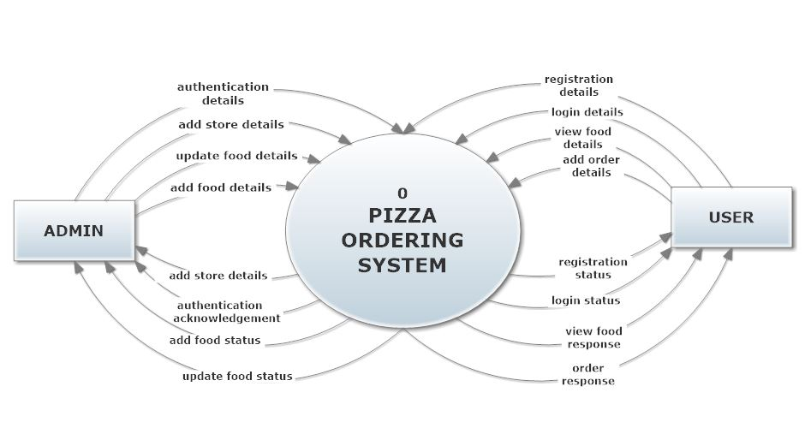

Figure 1: DFD-Level

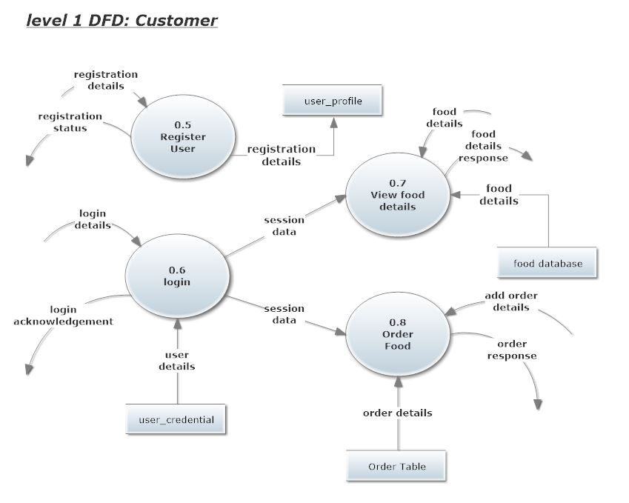

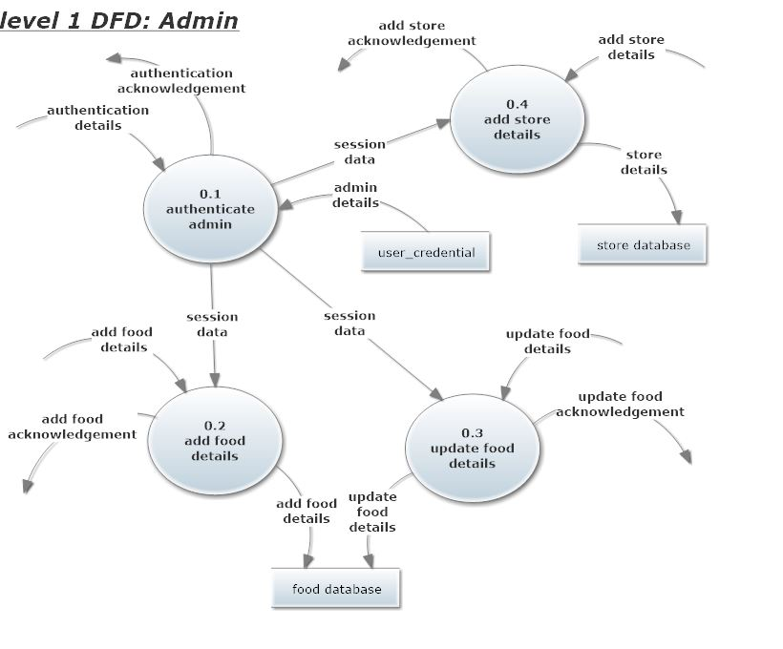

**4.5Use Case Diagrams**

**Use Case Diagram for Admin**

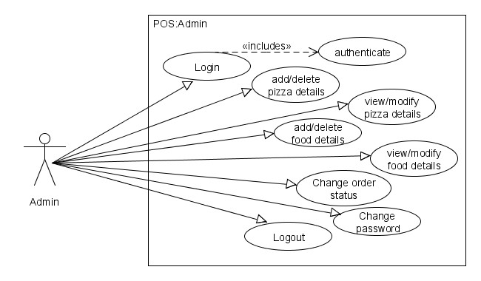

Figure 3: Use Case Diagram for Admin

**Use Case Diagram for Customer**

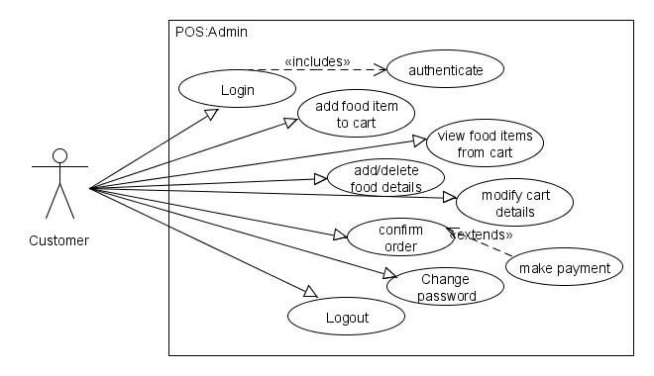Figure 4: Use Case Diagram for Customer

**Use Case Descriptions for Login Operation for all users**

#### Login

|  |  |
| --- | --- |
| **USE CASE #** | AA-001 *Login* |
| **Goal** | *All users logging into the system should be authenticated using a unique login-id and password (operations to be supported based on type of user)* |
| **Preconditions** | If the user type is ‘Admin’, credential details should exist.  If the user type is ‘Customer’, he/she should be registered by the administrator. |
| **Success End Condition** | If the user type is ‘Admin’, then redirect to the Admin page.  If the user type is ‘Customer’, then redirect to the Customer page. |
| **Failed End Condition** | *The end user is redirected to an Error Page, and/or is asked to re-enter login credentials.* |
| **Primary, Secondary Actors** | Admin, Customer. |
| **Trigger** | *Login button* |

|  |  |  |
| --- | --- | --- |
| **DESCRIPTION** | **Step** | **Action** |
| **1** | *Enter Login credentials (id & password)* |
| **2** | *Click on Login button* |
| **3** | *If id & password is Success, then identify user type Display appropriate(Admin/Customer) home page* |
| **Step** | **Branching Action** |
| **1** | *If 'id' is not existing then return with requesting for registration* |
| **2** | *If password is not matching return with suitable error message say 'Re-enter id & password'* |
| **Related**  **Information/Use cases** | *Not Applicable* | |
| **Priority** | *P1* | |
| **Performance** | *5 seconds* | |
| **Frequency** | *10 / hour* | |
| **Assumptions** | Admin/Customer login credentials are available in the database and others are already registered with their credentials | |

**Use Case Descriptions for ADD Food Details Operation for Admin only**

|  |  |  |
| --- | --- | --- |
| **USE CASE #** | AD-001 *The admin should be able to modify food items details* | |
| **Goal** | *To enable Administrator to create and add new Food Item* | |
| **Preconditions** | Administrator must be logged in to be able to create a new Food. | |
| **Success End Condition** | *“Redirect to Admin home page”* | |
| **Failed End Condition** | *"Redirect to Error Page"* | |
| **Primary, Secondary Actors** | *Administrator* | |
| **Trigger** | *'Add Food button* | |
| **DESCRIPTION** | **Step** | **Action** |
| **1** | *Provide appropriate food details* |
| **2** | *Click on Add food button* |
| **Step** | **Branching Action** |
| **1** | *If failed to add food details* |
| **2** | *Display appropriate message to the admin* |
| **Related**  **Information/Use cases** | *Not applicable* | |
| **Priority** | *P1* | |
| **Performance** | *Approx. 4 sec* | |
| **Frequency** | *2 / Month* | |
| **Assumptions** | Admin login credentials are available in the database | |

**4.6 Software Requirements**

**Frond End**

1. PHP & HTML

**Middle End**

1. Servlet

**Application Server**

1. MY SQL

**Database Server**

1. MY SQL

**Hardware Requirements**

|  |  |  |  |
| --- | --- | --- | --- |
| **Client Machine** | | **Server Machine** | |
| **HDD** | 200 MB | **HDD** | 320 GB |
| **Processor** | Dual Core or newer processor | **Processor** | Dual Core or newer processor |
| **Memory** | 1 GB | **Memory** | 4 GB |

**5. System Design**

**5.1 Database Design: ER Diagram**

**Order**

Place

**Customer**

**1 n**

**1**

**n**

has

**n**

**Pizza**

**n**

Finalizes

Pizza Ingredients

**1 n**

Add new

**Ingredients**

**1 n**

**Employee**

**Normalization :**

All the tables are normalized up to 3NF.

**5.2 Table Design**

**5.2.1Table Definition**

## 

## 1. Table: Marias_user

This table contains Authentication Information for Administrator & Customer

|  |  |  |
| --- | --- | --- |
| **Field Name** | **Data Type** | **Description** |
| id * | INT(30) | Primary Key |
| Username | VARCHAR(20) | Null |
| Password | VARCHAR(20) | Null |
| Loginstatus | NUMBER(1) | Either [1 ,0] |
| Date of registration | VARCHAR(30) | Null |

**\*** Id is an auto generated number .

## 

## 2. Table: Marias_members

This table contains User specific details entered during User Registration.

|  |  |  |
| --- | --- | --- |
| **Field Name** | **Data Type** | **Description** |
| Id* | INT(30) | Primary Key |
| Firstname | VARCHAR(30) | Null |
| Lastname | VARCHAR(30) | Null |
| Email | VARCHAR(50) | Null |
| Password | VARCHAR(20) | Null |
| Phone Number | VARCHAR(13) | Null |
| House No. | VARCHAR(15) | Null |
| Street Name | VARCHAR(50) | Null |
| City | VARCHAR(50) | Null |
| Pincode | VARCHAR(6) | Null |

**\*** Id is an auto generated number .

## 3. Table: Marias_products

This table contains Food specific information.

|  |  |  |
| --- | --- | --- |
| **Field Name** | **Data Type** | **Description** |
| Id* | INT(30) | Primary Key |
| Product_id | INT(30) | Null |
| Product_name | VARCHAR(50) | Null |
| Product_price | INT(10) | Null |
| Product_size_name | VARCHAR(50) | Null |
| Product_photo | VARCHAR(50) | Null |
| Product_ingredients | VARCHAR(50) | Null |
| Status | VARCHAR(30) | Null |

**\*** Id is an auto generated number .

## 4. Table: Marias_orders

This table contains Order details like Name, address etc.

|  |  |  |
| --- | --- | --- |
| **Field Name** | **Data Type** | **Description** |
| Id* | INT(50) | Primary Key |
| Cusid | INT(50) | Null |
| Amountpaid | VARCHAR(30) | Null |
| Status | VARCHAR(20) | Null |
| Transactiondate | VARCHAR(30) | Null |
| Transactioncode | VARCHAR(30) | Null |
| Mode | VARCHAR(30) | Null |

**\*** Id is an auto generated number .

## 5. Table: Order_details

This table contains details about order confirm by customer etc.

|  |  |  |
| --- | --- | --- |
| **Field Name** | **Data Type** | **Description** |
| Order_id | INT(50) | Primary Key |
| Customer | VARCHAR(30) | Null |
| Qty | VARCHAR (20) | Null |
| Price | VARCHAR (20) | Null |
| Total | VARCHAR(30) | Null |
| Pizza_name | VARCHAR(50) | Null |
| Pizza_size | VARCHAR(30) | Null |
| Transaction_code | VARCHAR(30) | Null |

**\*** Id is an auto generated number .

## 6. Table: Destination

This table contains details about where food to be delivered etc.

|  |  |  |
| --- | --- | --- |
| **Field Name** | **Data Type** | **Description** |
| Id* | INT(50) | Primary Key |
| Code | VARCHAR(50) | Null |
| Dist | VARCHAR (100) | Null |
| Agreement | VARCHAR (100) | Null |
| Person | VARCHAR(100) | Null |
| Time | VARCHAR(50) | Null |

**\*** Id is an auto generated number

## 7. Table: Inventory

This table contains details about Product left in the pizza store etc.

|  |  |  |
| --- | --- | --- |
| **Field Name** | **Data Type** | **Description** |
| Id* | INT(50) | Primary Key |
| Name | VARCHAR(50) | Null |
| Qtyleft | INT(50) | Null |
| Qtysold | INT(50) | Null |
| Product_id | VARCHAR(100) | Null |

**\*** Id is an auto generated number

**5.3 Form Design**

**5.3.1Components of Form**

HTML-5 and PHP

**5.4 Home Page :- Home.php**

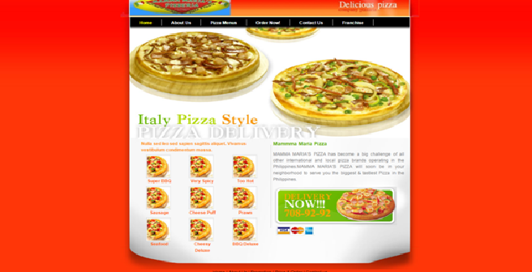

**5.5.PagesMenu-Card:Menu_card.php**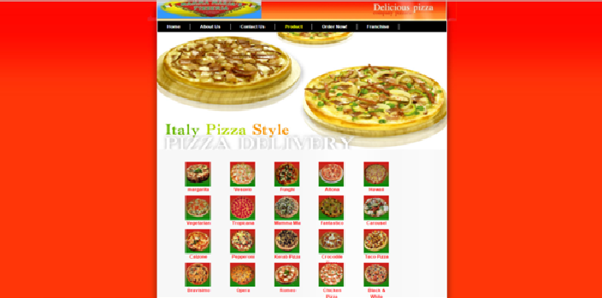

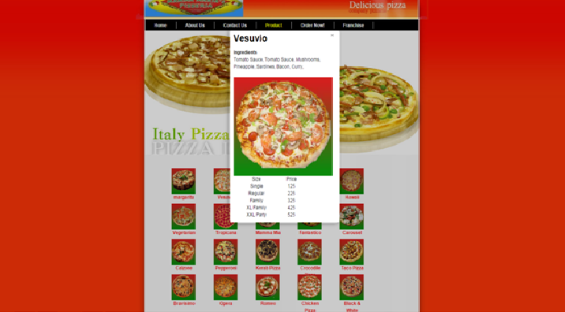

**Order Page: order-page.php**

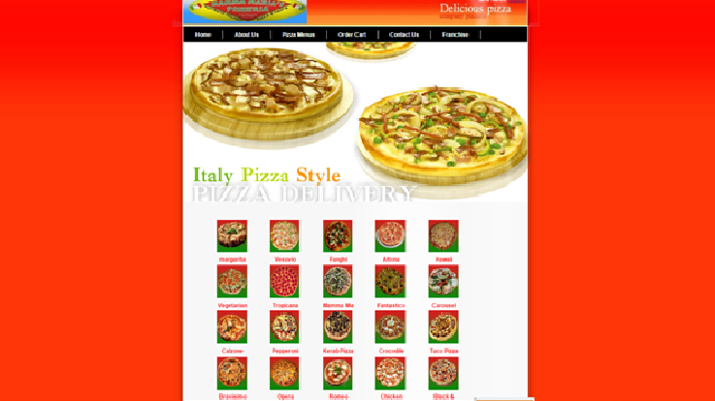

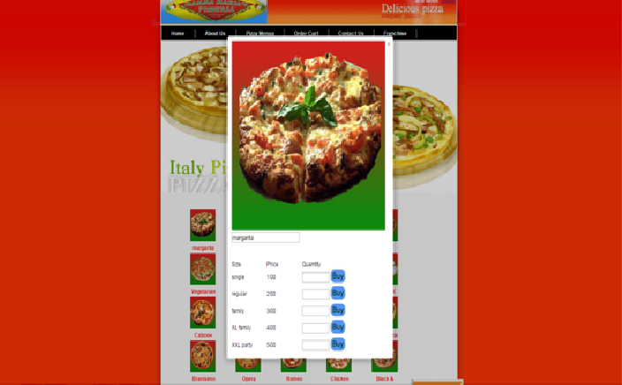

**Registration Page: registration.php**

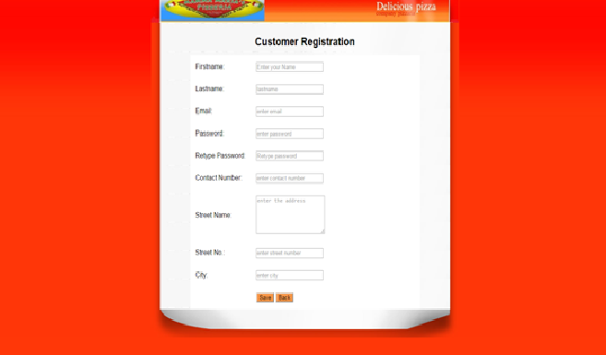

**Food List(ADMIN): food.php**

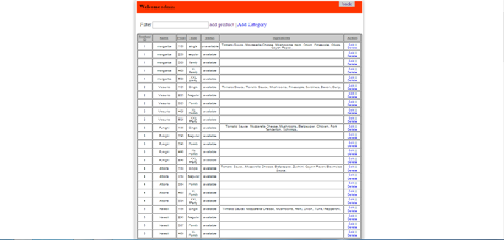

**Purchase Order Cart : PurchaseCart.php**

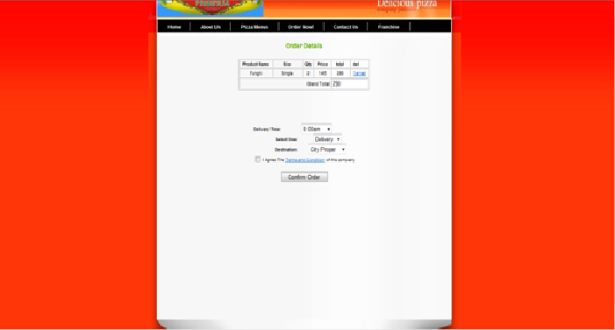

**6. Coding**

<head>

<meta http-equiv="Content-Type" content="text/html; charset=utf-8" />

<title> About Us</title>

<link href="templatemo_style.css" rel="stylesheet" type="text/css" />

</head>

<body>

<div id="templatemo_container">

<div id="templatemo_header_section">

</div>

<div id="templatemo_menu_bg">

<div id="templatemo_menu">

<ul>

<li><a href="index.html">Home</a></li>

<li><a href="aboutus.html" class="current">About Us</a></li>

<li><a href="product.php">Pizza Menus</a></li>

<li><a href="loginindex">Order Now!</a></li>

<li><a href="contact.php">Contact Us</a></li>

<li><a href="franchise.php">Franchise</a></li>

</ul>

</div>

</div>

<div id="templatemo_header_pizza">

</div>

<div id="templatemo_content_bg">

<div id="templatemo_content_2">

<h2>Welcome to Mamma Maria's Pizza</h2>

<p>The pizza creator’s idea was to come up with an authentic thin crunchy Italiano pizza crust with flavors that would suit the taste of the Filipino.

</p>

<h2>About Us</h2>

<p>The first branch MAMMA MARIA’S PIZZA was opened in Bacolod City, in December of 2005. It was an immediate success, five more branches were opened in 2006, to serve the thousands of pizza patriots who ordered their favorite pizza flavors.<br />

&nbsp;&nbsp;&nbsp;&nbsp;&nbsp;&nbsp;&nbsp;&nbsp;MAMMA MARIA’S PIZZA has become a big challenge of all other international and local pizza brands operating in the Philippines.MAMMA MARIA’S PIZZA will soon be in your neighborhood to serve you the biggest & tastiest Pizza in the Philippines.</p>

<p>The special dough mix of the pizza is rolled right in front of the customer so they can see the entire process of the preparation. The best quality toppings are used to give the customer the famous original MAMMA MARIA’S PIZZA.</p>

</div>

</div>

<div id="templatemo_container_end">

</div>

</div>

<div id="templatemo_footer">

<div class="top">

<a href="#">Home</a> | <a href="#">About Us</a> | <a href="#">Promotion</a> | <a href="#">Price &amp; Order</a> | <a href="#">Contact us</a>

</div>

<div class="middle">

Copyright © Mamma Maria's Pizza

</div>

<div class="button"></div>

</div>

<div>

</div>

</body>

</html>

<?php

//Start session

session_start();

//Unset the variables stored in session

unset($_SESSION['SESS_MEMBER_ID']);

unset($_SESSION['SESS_FIRST_NAME']);

?>

<!doctype html>

<?php

include("config.php");

?>

<html>

<head>

<meta charset="utf-8">

<title>login</title>

<link href="templatemo_style.css" rel="stylesheet" type="text/css">

<link href="src/facebox.css" media="screen" rel="stylesheet" type="text/css" />

<script src="lib/jquery.js" type="text/javascript"></script>

<script src="src/facebox.js" type="text/javascript"></script>

<script type="text/javascript">

jQuery(document).ready(function($) {

$('a[rel*=facebox]').facebox({

loadingImage : 'src/loading.gif',

closeImage : 'src/closelabel.png'

})

})

</script>

<!--sa validate from-->

<script type="text/javascript" src="validation/js/jquery-1.11.3.js"></script>

<script type="text/javascript" src="validation/js/jquery.validate.js"></script>

<style type="text/css">

label.error

{

width:auto;

height:auto;

margin-left:15px;

background:#C00;

color:#FFF;

font-family:"Times New Roman", Times, serif;

font-style:italic;

padding:5px;

border-radius:4px;

box-shadow:3px 3px 3px #999999;

}

</style>

</head>

<body>

<div id="templatemo_container">

<div id="templatemo_header_section">

</div>

<div id="templatemo_menu_bg">

<div id="templatemo_menu">

<ul>

<li><a href="index.html">Home</a></li>

<li><a href="aboutus.html">About Us</a></li>

<li><a href="product.php">Pizza Menus</a></li>

<li><a href="loginindex.php" class="current">Order Now!</a></li>

<li><a href="contact.php">Contact Us</a></li>

<li><a href="franchise.php">Franchise</a></li>

</ul>

</div>

<div style="width:300px; height:50px;">

</div>

<h1 style="margin:0; padding:0; text-align:center; color:#000;"> Member Login </h1>

<div style="width:300px; height:20px;">

</div>

<script>

$(document).ready(function() {

jQuery.validator.addMethod("lettersOnly",function(value,element) {

return this.optional(element)||value == value.match(/^[a-zA-Z]+$/);

},"Only alphabets Allowed.");

jQuery.validator.addMethod("phone",function (value,element){

return this.optional(element)||value == value.match(/^\d{10}$/);},"10 digit mobile number only.");

jQuery.validator.addMethod("emai",function (value,element){

return this.optional(element) ||value == value.match(/^\w+([\.-]?\w+)*@\w+([\.-]?\w+)*(\.\w{2,3})+$/);},"Invalid Email Id .");

jQuery.validator.addMethod("retype",function (value,element){

return this.optional(element) ||value == value.match(pass);},"Invalid Email Id .");

jQuery.validator.addMethod("city",function (value,element){

return this.optional(element) ||value == value.match('');},"Please Select your city");

$("#frm").validate({

rules:{

user:{

required:true

},

password:{

required:true,

minlength:8

}

},

messages:{

user:{

required:'Please enter your email id'

},

password:{

required:'Please enter your password'

}

}

});

});

</script>

<center> <form name="frm" id="frm" method="post" action="loginexec.php">

<?php

if( isset($_SESSION['ERRMSG_ARR']) && is_array($_SESSION['ERRMSG_ARR']) && count($_SESSION['ERRMSG_ARR']) >0 ) {

echo '<ul class="err">';

foreach($_SESSION['ERRMSG_ARR'] as $msg) {

echo '<li>',$msg,'</li>';

}

echo '</ul>';

unset($_SESSION['ERRMSG_ARR']);

}

?>

<table cellpadding="10" cellspacing="5" id="templatemo_content_blank" class="textblank">

<tr>

<td width="130"> Email: </td>

<td width="392"><input type="text" name="user" required placeholder="Enter your email"></td>

</tr>

<tr>

<td> Password: </td>

<td><input type="password" name="password" required placeholder="enter password"></td>

</tr>

<tr>

<td>&nbsp; </td>

<td> <center> <input type="Submit" name="Submit" value="Login" id="button"></center></td>

</tr>

</table>

</form>

</center>

<center><a href="registration.php" id="hrefsize"> New User?Register </a></center>

</div>

</body>

</html>

<?php

require_once('auth.php');

?>

<!doctype html>

<html>

<head>

<meta charset="utf-8">

<title>Untitled Document</title>

<link href="templatemo_style.css" rel="stylesheet" type="text/css">

<link href="src/facebox.css" media="screen" rel="stylesheet" type="text/css" />

<script src="lib/jquery.js" type="text/javascript"></script>

<script src="src/facebox.js" type="text/javascript"></script>

<script type="text/javascript">

jQuery(document).ready(function($) {

$('a[rel*=facebox]').facebox({

loadingImage : 'src/loading.gif',

closeImage : 'src/closelabel.png'

})

})

</script>

<script type="text/javascript">

function ShowTime()

{

var time=new Date()

var h=time.getHours()

var m=time.getMinutes()

var s=time.getSeconds()

// add a zero in front of numbers<10

m=checkTime(m)

s=checkTime(s)

document.getElementById('txt').value=h+" : "+m+" : "+s

t=setTimeout('ShowTime()',1000)

}

function checkTime(i)

{

if (i<10)

{

i="0" + i

}

return i

}

</script>

<script type="text/javascript">

function showDiv(prefix,chooser)

{

for(var i=0;i<chooser.options.length;i++)

{

var div = document.getElementById(prefix+chooser.options[i].value);

div.style.display = 'none';

}

var selectedOption = (chooser.options[chooser.selectedIndex].value);

if(selectedOption == "1")

{

displayDiv(prefix,"1");

}

else if(selectedOption == "2")

{

displayDiv(prefix,"2");

}

}

function displayDiv(prefix,suffix)

{

var div = document.getElementById(prefix+suffix);

div.style.display = 'block';

}

</script>

</head>

<body onLoad="ShowTime()">

<div id="templatemo_container">

<div id="templatemo_header_section"><div style="float:right; margin-right:30px;">

<?php

include('config.php');

$id=$_SESSION['SESS_MEMBER_ID'];

$resulta = mysql_query("SELECT * FROM marias_members WHERE id = '$id'");

while($row = mysql_fetch_array($resulta))

{

echo $row['firstname'] .' '. $row['lastname'];

}

?>&nbsp;<a href="index.html">&nbsp;logout</a></div>

</div>

<div id="templatemo_menu_bg">

<div id="templatemo_menu">

<ul>

<li><a href="index.html">Home</a></li>

<li><a href="aboutus.html">About Us</a></li>

<li><a href="product.php">Pizza Menus</a></li>

<li><a href="shoppingcart.php">Order Cart</a></li>

<li><a href="contact.php">Contact Us</a></li>

<li><a href="franchise.php">Franchise</a></li>

</ul>

</div>

</div>

<div id="templatemo_header_pizza"> </div>

<div id="templatemo_content_left1">

<div class="view1"><?php

include('config.php') $result2 = mysql_query("SELECT * FROM category") while($row2 = mysql_fetch_array($result2))

{

$ble=$row2['id']

$result3 = mysql_query("SELECT * FROM marias_products where product_id='$ble'"); $row3 = mysql_fetch_array($result3);

echo '<div class="templatemo_pizza_box"> <a rel="facebox" href=portal.php?id=' . $row3["product_id"] . '><img alt="Pizza" src="images/pizza/'.$row3['product_photo'].'" width="65px" height="65px" /></a>';

echo '<div class="textbox"> '.$row3['product_name'].' </div>';

echo '</div>';

}

?></div>

<div id="templatemo_card">

</div>

</div>

<div>

</div>

<div>

&nbsp;

&nbsp;

&nbsp;

</br>

<p>

</div>

<div id="templatemo_container_end">

</div>

</div>

<div id="templatemo_footer">

<div class="middle">

Copyright © Mamma Maria's Pizza</div>

<div class="button"></div>

</div>

<div>

</div>

</body>

</html>

<!DOCTYPE html PUBLIC "-//W3C//DTD XHTML 1.0 Transitional//EN" "http://www.w3.org/TR/xhtml1/DTD/xhtml1-transitional.dtd">

<html xmlns="http://www.w3.org/1999/xhtml">

<head>

<meta http-equiv="Content-Type" content="text/html; charset=utf-8" />

<title>Mamma Maria's Pizza</title>

<meta name="keywords" content="free website templates, CSS layout, Pizza Company Website, HTML CSS" />

<meta name="description" content="Pizza Company Website - free CSS website template, Free HTML CSS Layout" />

<link href="templatemo_style.css" rel="stylesheet" type="text/css" />

<link href="src/facebox.css" media="screen" rel="stylesheet" type="text/css" />

<script src="lib/jquery.js" type="text/javascript"></script>

<script src="src/facebox.js" type="text/javascript"></script>

<script type="text/javascript">

jQuery(document).ready(function($) {

$('a[rel*=facebox]').facebox({

loadingImage : 'src/loading.gif',

closeImage : 'src/closelabel.png'

})

})

</script>

</head>

<body>

<div id="templatemo_container">

<div id="templatemo_header_section"> </div>

<div id="templatemo_menu_bg">

<div id="templatemo_menu">

<ul>

<li><a href="index.html">Home</a></li>

<li><a href="aboutus.html">About Us</a></li>

<li><a href="contact.php">Contact Us</a></li>

<li><a href="product.php" class="current">Product</a></li>

<li><a href="loginindex.php">Order Now! </a></li>

<li><a href="franchise.php">Franchise</a></li>

</ul>

</div>

</div>

<div id="templatemo_header_pizza"> </div>

<div class="con">

<div id="templatemo_content_left1">

<?php

include('config.php');

$result2 = mysql_query("SELECT * FROM category");

while($row2 = mysql_fetch_array($result2))

{

$ble=$row2['id'];

$result3 = mysql_query("SELECT * FROM marias_products where product_id='$ble'");

$row3 = mysql_fetch_array($result3);

echo '<div class="templatemo_pizza_box"> <a rel="facebox" href=large.php?id=' . $row3["product_id"] . '><img alt="Pizza" src="images/pizza/'.$row3['product_photo'].'" width="65px" height="65px" /></a>';

echo '<div class="textbox">'.$row3['product_name'].' </div>';

echo '</div>';

?>

</div>

</div>

<div>

<br />

<br/>

</div>

<div id="templatemo_container_end">

</div>

<div id="templatemo_footer">

<div class="top"></div>

</div>

</div>

</body>

</body>

</html>

<!doctype html>

<?php

include("config.php");

?>

<html>

<head>

<meta charset="utf-8">

<title>Registration</title>

<link href="templatemo_style.css" rel="stylesheet" type="text/css">

<script src="lib/jquery.js" type="text/javascript"></script>

<script src="src/facebox.js" type="text/javascript"></script>

<script type="text/javascript">

jQuery(document).ready(function($) {

$('a[rel*=facebox]').facebox({

loadingImage : 'src/loading.gif',

closeImage : 'src/closelabel.png'

})

})

</script>

<!--sa validate from-->

<script type="text/javascript" src="validation/js/jquery-1.11.3.js"></script>

<script type="text/javascript" src="validation/js/jquery.validate.js"></script>

<style type="text/css">

label.error

{

width:auto;

height:auto;

margin-left:15px;

background:#C00;

color:#FFF;

font-family:"Times New Roman", Times, serif;

font-style:italic;

padding:5px;

border-radius:4px;

box-shadow:3px 3px 3px #999999;

}

</script>

</style>

<script>

function showUser(str)

{

//if(str=="")

//{

//document.getElementById("txtHint").innerHTML="Please enter your email";

//return;

//}

if(window.XMLHttpRequest)

{

xmlhttp=new XMLHttpRequest(); //google crome,IE8,opera

}

else

{

xmlhttp=new ActiveXObject("Microsoft.XMLHTTP"); //IE5,Morzila

}

xmlhttp.onreadystatechange=function()

{

if(xmlhttp.readyState==4 && xmlhttp.status==200)

{

document.getElementById("txtHint").innerHTML=xmlhttp.responseText;

}

}

xmlhttp.open("GET","check_email.php?q="+str,true);

xmlhttp.send();

}

</script>

</head>

<body>

<div id="templatemo_container">

<div id="templatemo_header_section">

</div>

<div id="templatemo_content_box">

<div style="width:300px; height:30px;">

</div>

<h1 style="margin:0; padding:0; text-align:center; color:#000;"> Customer Registration</h1>

<div style="width:300px; height:20px;">

</div>

<script>

$(document).ready(function() {

jQuery.validator.addMethod("lettersOnly", function(value,element) {

return this.optional(element) || value == value.match(/^[a-zA-Z]+$/);

},"Only alphabets Allowed.");

jQuery.validator.addMethod("phone",function (value,element){

return this.optional(element) ||value == value.match(/^\d{10}$/);},"10 digit mobile number only.");

jQuery.validator.addMethod("emai",function (value,element){

return this.optional(element) ||value == value.match(/^\w+([\.-]?\w+)*@\w+([\.-]?\w+)*(\.\w{2,3})+$/);},"Invalid Email Id .");

jQuery.validator.addMethod("retype",function (value,element){

return this.optional(element) ||value == value.match("#pass");},"Incorrect Password");

$("#form1").validate({

rules:{

nm:{

required:true,

lettersOnly:true

},

lm:{

required:true,

lettersOnly:true

},

email:{

required:true,

},

pass:{

required:true,

minlength:8

},

repass:{

required:true,

minlength:8,

equalTo:("#pass")

},

num:{

required:true,

phone:true

},

ad:{

required:true

},

stnum:{

required:true

},

city:{

required:true

}

},

messages:{

nm:{

required:'Please enter your firstname'

},

lm:{

required:'Please enter your lastname'

},

email:{

required:'Please enter your email'

},

pass:{

required:'Please enter your password'

},

repass:{

required:'Please Confirm password',

equalTo:'Incorrect Password'

},

num:{

required:'Please enter contact no.'

},

ad:{

required:'Please enter your address'

},

stnum:{

required:'Please enter your street No.'

},

city:{

required:'Please enter City'

}

}

});

});

</script>

<center> <form id="form1" name="form1" method="post">

<table cellpadding="12" lcellspacing="8" id="templatemo_content_blank" class="textblank">

<tr>

<td width="154"> Firstname: </td>

<td width="477"><input type="text" name="nm" required placeholder="Enter your Name" class="textboxx" id="fname_error"> </td>

</tr>

<tr>

<td> Lastname: </td>

<td><input type="text" name="lm" id="lname_error" required placeholder="lastname"></td>

</tr>

<tr>

<td> Email: </td>

<td><input type="text" name="email" required placeholder="enter email" onBlur="showUser(this.value)"><label id="txtHint" ></label></td>

</tr>

<tr>

<td> Password: </td>

<td><input type="password" name="pass" required placeholder="enter password" id="pass"></td>

</tr>

<tr>

<td> Confirm Password: </td>

<td><input type="password" name="repass" required placeholder="Retype password" id="repass"></td>

</tr>

<tr>

<td> Contact Number: </td>

<td><input type="text" name="num" required placeholder="enter contact number"></td>

</tr>

<tr>

<td> Street Name: </td>

<td><textarea name="ad" required placeholder="enter the address" cols="22" rows="5"></textarea></td>

</tr>

<tr>

<td> Street No.: </td>

<td><input type="text" name="stnum" required placeholder="enter street number"></td>

</tr>

<tr>

<td> City: </td>

<td><input type="text" name="city" required placeholder="enter city"></td>

</tr>

<tr>

<td>&nbsp; </td>

<td><input type="submit" name="sb" id="button" value="Save" height="5">

<a href="loginindex.php"><input type="button" id="button" value="Back"></a></td>

</tr>

</table>

<?php

if(isset($_POST['sb']))

{

$fname=$_POST['nm'];

$lname=$_POST['lm'];

$email=$_POST['email'];

$pass=$_POST['pass'];

$cnum=$_POST['num'];

$st=$_POST['ad'];

$stn=$_POST['stnum'];

$cit=$_POST['city'];

$sql="INSERT INTO `marias_members` (`firstname`,`lastname`,`email`,`password`,`number`,`house1`,`street`,`city`) VALUES ('$fname','$lname','$email','$pass','$cnum','$st','$stn','$cit')";

$res=mysql_query($sql);

}

?>

<?php

if(isset($_POST['bk']))

{

header("location:loginindex.php");

exit();

}

?>

</form></center>

</div>

<div>

</div>

<div id="templatemo_container_end">

</div>

</div>

</div>

</body>

</html>

<?php

require_once('auth.php');

?>

<!doctype html>

<html>

<head>

<meta charset="utf-8">

<title>Untitled Document</title>

<link href="../user/templatemo_style.css" rel="stylesheet" type="text/css">

<meta http-equiv="Content-Type" content="text/html; charset=utf-8" />

<title> Home </title>

<meta name="keywords" content="free website templates, CSS layout, Pizza Company Website, HTML CSS" />

<meta name="description" content="Pizza Company Website - free CSS website template, Free HTML CSS Layout" />

<script type="text/javascript">

function validateForm()

{

if (document.abcd.checkbox.checked == false)

{

alert ('pls. agree the term and condition of this company');

return false;

}

else

{

return true;

}

}

</script>

</head>

<body>

<div id="templatemo_container">

<div id="templatemo_header_section">

</div>

<div id="templatemo_menu_bg">

<div id="templatemo_menu">

<ul>

<li><a href="index.html">Home</a></li>

<li><a href="aboutus.html">About Us</a></li>

<li><a href="product.php">Pizza Menus</a></li>

<li><a href="ordertest.php">Order Now!</a></li>

<li><a href="contact.php">Contact Us</a></li>

<li><a href="franchise.php">Franchise</a></li>

</ul>

</div>

</div>

<div id="templatemo_content_bg">

<div>

<br/>

</div>

<center>

<form method="post" action="paymentportal.php" name="abcd" onsubmit="return validateForm()">

<input name="cusid" type="hidden" value="<?php echo $_SESSION['SESS_MEMBER_ID']; ?>" />

<input name="transactioncode" type="hidden" value="<?php echo $_SESSION['SESS_FIRST_NAME']; ?>" />

<h2>Order Details </h2>

<table width="335" border="1" cellpadding="0" cellspacing="0" style="color:#000000; font-family:Arial, Helvetica, sans-serif; font-size:10px;">

<tr>

<td width="90"><div align="center"><strong>Product Name </strong></div></td>

<td width="84"><div align="center"><strong>Size</strong></div></td>

<td width="27"><div align="center"><strong>Qty</strong></div></td>

<td width="45"><div align="center"><strong>Price</strong></div></td>

<td width="46"><div align="center"><strong>total</strong></div></td>

<td width="29"><div align="center"><strong>del</strong></div></td>

</tr>

<?php

include('config.php');

$memid = $_SESSION['SESS_FIRST_NAME'];

$resulta = mysql_query("SELECT * FROM orderdetails WHERE transactioncode = '$memid'");

while($row = mysql_fetch_array($resulta))

{

echo '<tr>';

echo '<td><div align="center">'.$row['pizzaname'].'</div></td>';

echo '<td><div align="center">'.$row['pizasize'].'</div></td>';

echo '<td><div align="center">'.$row['qty'].'</div></td>';

echo '<td><div align="center">'.$row['price'].'</div></td>';

echo '<td><div align="center">'.$row['total'].'</div></td>';

echo '<td><div align="center">'.'<a href=deleteorder.php?id=' . $row["orderid"] . '>' . 'Cancel' . '</a>'.'</div></td>';

echo '</tr>';

}

?>

<tr>

<td colspan="4"><div align="right">Grand Total: </div></td>

<td colspan="2"><div align="left">

<?php

include('config.php');

$memid = $_SESSION['SESS_FIRST_NAME'];

$result = mysql_query("SELECT sum(total) FROM orderdetails WHERE transactioncode = '$memid'");

while($rows = mysql_fetch_array($result))

{

echo '<input name="total" type="text" size="10" value="'.$rows['sum(total)'].'"/>';

}

?>

</div></td>

</tr>

</table>

<p>&nbsp;</p>

<p><br />

</p>

<table width="273" border="0" cellpadding="0" cellspacing="0" style="color:#000000; font-family:Arial, Helvetica, sans-serif; font-size:10px;">

<tr>

<td width="76"><div align="right"><strong>Delivery Time:</strong></div></td>

<td width="97"><select name="time">

<option value="8:00am">8:00am</option>

<option value="8:15am">8:15am</option>

<option value="8:30am">8:30am</option>

<option value="8:45am">8:45am</option>

<option value="9:00am">9:00am</option>

<option value="9:15am">9:15am</option>

<option value="9:30am">9:30am</option>

<option value="9:45am">9:45am</option>

<option value="10:00am">10:00am</option>

<option value="10:15am">10:15am</option>

<option value="10:30am">10:30am</option>

<option value="10:45am">10:45am</option>

<option value="11:00am">11:00am</option>

<option value="11:15am">11:15am</option>

<option value="11:30am">11:30am</option>

<option value="11:45am">11:45am</option>

<option value="12:00pm">12:00pm</option>

<option value="12:15pm">12:15pm</option>

<option value="12:30pm">12:30pm</option>

<option value="12:45pm">12:45pm</option>

<option value="1:00pm">1:00pm</option>

<option value="1:15pm">1:15pm</option>

<option value="1:30pm">1:30pm</option>

<option value="1:45pm">1:45pm</option>

<option value="2:00pm">2:00pm</option>

<option value="2:15pm">2:15pm</option>

<option value="2:30pm">2:30pm</option>

<option value="2:45pm">2:45pm</option>

<option value="3:00pm">3:00pm</option>

<option value="3:15pm">3:15pm</option>

<option value="3:30pm">3:30pm</option>

<option value="3:45pm">3:45pm</option>

<option value="4:00pm">4:00pm</option>

<option value="4:15pm">4:15pm</option>

<option value="4:30pm">4:30pm</option>

<option value="4:45pm">4:45pm</option>

<option value="5:00pm">5:00pm</option>

<option value="5:15pm">5:15pm</option>

<option value="5:30pm">5:30pm</option>

<option value="5:45pm">5:45pm</option>

<option value="6:00pm">6:00pm</option>

<option value="6:15pm">6:15pm</option>

<option value="6:30pm">6:30pm</option>

<option value="6:45pm">6:45pm</option>

<option value="7:00pm">7:00pm</option>

<option value="7:15pm">7:15pm</option>

<option value="7:30pm">7:30pm</option>

<option value="7:45pm">7:45pm</option>

<option value="8:00pm">8:00pm</option>

<option value="8:15pm">8:15pm</option>

<option value="8:30pm">8:30pm</option>

<option value="8:45pm">8:45pm</option>

<option value="9:00pm">9:00pm</option>

<option value="9:15pm">9:15pm</option>

<option value="9:30pm">9:30pm</option>

<option value="9:45pm">9:45pm</option>

<option value="10:00pm">10:00pm</option>

<option value="10:15pm">10:15pm</option>

<option value="10:30pm">10:30pm</option>

<option value="10:45pm">10:45pm</option>

<option value="11:00pm">11:00pm</option>

<option value="11:15pm">11:15pm</option>

<option value="11:30pm">11:30pm</option>

<option value="11:45pm">11:45pm</option>

<option value="12:00am">12:00am</option>

</select></td>

</tr>

<tr>

<td><div align="right"><strong>Select One:</strong></div></td>

<td><select name="portal" id="cboOptions" onChange="showDiv('div',this)">

<option value="1">Delivery</option>

<option value="2">Pick-Up</option>

</select>

</select></td>

</tr>

<div id="div1" style="display:none; color:#000000">

&nbsp;Delivery Destination:<input name="dist" type="text" />

</div>

<div id="div2" style="display:none; color:#000000">

&nbsp;&nbsp;&nbsp;&nbsp;&nbsp;&nbsp;&nbsp;&nbsp;&nbsp;&nbsp;Recepient:<input name="person" type="text" />

</div>

<tr>

<td><div align="right"><strong>Destination:</strong></div></td>

<td><select name="destination" id="distination">

<option value="City Proper">City Proper</option>

<option value="Outside City">Outside City</option>

</select></td>

</tr>

<tr>

<td colspan="2"><label>

<input type="checkbox" name="checkbox" value="checkbox" />

I Agree The <a rel="facebox" href="terms.php">Terms and Condition</a> of this company</label></td>

</tr>

</table><br />

<input name="" type="submit" value="Confirm Order" />

</form>

</center>

</div>

<div id="template_content_f">

</div>

<div id="templatemo_container_end">

</div>

</div>

</body>

</html>

<!doctype html>

<html>

<head>

<meta charset="utf-8">

<title>Untitled Document</title>

<link href="../user/templatemo_style.css" rel="stylesheet" type="text/css">

<style type="text/css">

<!--

.style1 {

font-size: 16px;

font-weight: bold;

}

-->

</style>

</head>

<body>

<div id="templatemo_container">

<div id="templatemo_header_section"> </div>

<div id="templatemo_menu_bg">

<div id="templatemo_menu">

<ul>

<li><a href="index.html">Home</a></li>

<li><a href="aboutus.html">About Us</a></li>

<li><a href="contact.php" class="current">Contact Us</a></li>

<li><a href="product.php">Product</a></li>

<li><a href="loginindex.php">Order Now! </a></li>

<li><a href="franchise.php">Franchise</a></li>

</ul>

</div>

</div>

<div id="templatemo_header_pizza"> </div>

<div id="templatemo_content">

<div id="templatemo_content_left">

<div class="text" style="color:#000000">

<iframe width="685" height="300" frameborder="0" scrolling="no" marginheight="0" marginwidth="0" src="http://maps.google.com.ph/maps?f=q&amp;source=s_q&amp;hl=en&amp;geocode=&amp;q=Bacolod+City,+Western+Visayas&amp;aq=0&amp;oq=bacolod+city&amp;sll=12.867031,121.766552&amp;sspn=22.691867,43.286133&amp;ie=UTF8&amp;hq=&amp;hnear=Bacolod+City,+Negros+Occidental,+Western+Visayas&amp;t=m&amp;ll=10.671368,122.951506&amp;spn=0.001845,0.003219&amp;z=18&amp;iwloc=lyrftr:m,15792293577711675161,10.670856,122.951109&amp;output=embed"></iframe><br />

</div>

</div>

</div>

<div id="templatemo_container_end">

</div>

</div>

</div>

</div>

</body>

</html>

<form action="addpro-exec.php" method="post" name="abc">

<table width="400" border="0" cellpadding="0">

<tr>

<td width="100" valign="top"><div align="right">Product ID:</div></td>

<td width="300"><div align="left"><input name="roomid" type="text" id="roomid"></div></td>

</tr>

<tr>

<td valign="top"><div align="right">Name:</div></td>

<td><div align="left"><?php

include('config.php');

$name= mysql_query("select * from category");

echo '<select name="name">';

while($res= mysql_fetch_assoc($name))

{

echo '<option value="'.$res['id'].'">';

echo $res['category'];

echo'</option>';

}

echo'</select>';

?></div></td>

</tr>

<tr>

<td valign="top"><div align="right">Price:</div></td>

<td><div align="left"><input name="price" type="text" id="price"></div></td>

</tr>

<tr>

<td valign="top"><div align="right">Size:</div></td>

<td><div align="left"><input name="size" type="text" id="size"></div></td>

</tr>

<tr>

<td valign="top"><div align="right">Size Name:</div></td>

<td><div align="left"><input type="text" name="sizem" id="sizee" /></div></td>

</tr>

<tr>

<td valign="top"><div align="right">Upload image:</div></td>

<td><div align="left"><input type="file" name="f1" id="fileto" /></div></td>

</tr>

<tr>

<td valign="top"><div align="right">Status:</div></td>

<td><div align="left"><select name="status" id="status">

<option selected>available</option>

<option>unavailable</option>

</select></div></td>

</tr>

<tr>

<td valign="top"><div align="right">Ingrdients:</div></td>

<td><div align="left"><textarea name="ing" cols="40" rows="5" id="ing">

</textarea></div></td>

</tr>

<tr>

<td valign="top"><div align="right"></div></td>

<td><input name="Input" type="submit" value="Save" /></td>

</tr>

</table>

</form>

<?php

require_once('auth.php');

?>

<?php

include('config.php');

$id="";

mysql_query("DELETE FROM marias_orders WHERE cusid='$id' or amountpaid='$id' or status='$id' or transactiondate='$id' or transactioncode='$id'");

?>

<!DOCTYPE html PUBLIC "-//W3C//DTD XHTML 1.0 Transitional//EN" "http://www.w3.org/TR/xhtml1/DTD/xhtml1-transitional.dtd">

<html xmlns="http://www.w3.org/1999/xhtml">

<head>

<meta http-equiv="Content-Type" content="text/html; charset=iso-8859-1" />

<title>Untitled Document</title>

<link href="css/ble.css" rel="stylesheet" type="text/css" />

<link href="css/main.css" rel="stylesheet" type="text/css" />

<!--sa poip up-->

<link href="src/facebox.css" media="screen" rel="stylesheet" type="text/css" />

<script src="lib/jquery.js" type="text/javascript"></script>

<script src="src/facebox.js" type="text/javascript"></script>

<script type="text/javascript">

jQuery(document).ready(function($) {

$('a[rel*=facebox]').facebox({

loadingImage : 'src/loading.gif',

closeImage : 'src/closelabel.png'

})

})

</script>

<!--sa validate from-->

<script type="text/javascript">

function validateForm()

{

var y=document.forms["login"]["user"].value;

var a=document.forms["login"]["password"].value;

if ((y==null || y==""))

{

alert("you must enter your username");

return false;

}

if ((a==null || a==""))

{

alert("you must enter your password");

return false;

}

}

</script>

<link rel="stylesheet" href="./febe/style.css" type="text/css" media="screen" charset="utf-8">

<script src="argiepolicarpio.js" type="text/javascript" charset="utf-8"></script>

<script src="./js/application.js" type="text/javascript" charset="utf-8"></script>

<style type="text/css">

<!--

a:link {

text-decoration: none;

}

a:visited {

text-decoration: none;

}

a:hover {

text-decoration: none;

}

a:active {

text-decoration: none;

}

-->

</style></head>

<body>

<div style="width:300px; margin:0 auto; position:relative; border:3px solid rgba(0,0,0,0); -webkit-border-radius:5px; -moz-border-radius:5px; border-radius:5px; -webkit-box-shadow:0 0 18px rgba(0,0,0,0.4); -moz-box-shadow:0 0 18px rgba(0,0,0,0.4); box-shadow:0 0 18px rgba(0,0,0,0.4); margin-top:10%;">

<div style="background-color:#ff3300; height:40px; margin-bottom:10px;">

<div style="float:right; width:50px; margin-right:20px; background-color:#cccccc; text-align:center;"><a href="admin_index.php">Logout</a></div>

<div style="float:left; margin-left:10px; margin-top:10px;"><strong>Welcome</strong> <?php echo $_SESSION['SESS_FIRST_NAME'];?></div>

</div>

<div align="center"><a href="viewmembers.php"><img src="images/54.png" border="0" style="padding:5px;" title="view all members" /></a><a href="allusers.php"><img src="images/47.png" border="0" style="padding:5px;" title="View all Users" /></a><a href="vieworders.php"><img src="images/84.png" border="0" style="padding:5px;" title="view all orders" /></a><br />

<a href="viewproducts.php"><img src="images/78.png" border="0" style="padding:5px;" title="view all products" /></a> <a href="sales.php"><img src="images/81.png" border="0" style="padding:5px;" title="sales report" /></a> <a href="inventory.php"><img src="images/49.png" border="0" style="padding:5px;" title="Inventory" /></a> </div>

</div>

</body>

</html>

<?php

session_start();

include('config.php');

$roomid=$_POST['roomid'];

$name=$_POST['name'];

$price=$_POST['price'];

$size=$_POST['size'];

$sizen=$_POST['sizem'];

$fname=$_FILES['f1']['name'];

$status=$_POST['status'];

$ing=$_POST['ing'];

mysql_query("INSERT INTO marias_products (product_id, product_name, product_price,product_size,product_size_name,product_photo,status, product_ingredients) VALUES('$roomid', '$name', '$price', '$size','$sizen','$fname','$status', '$ing')");

header("location: viewproducts.php");

mysql_close($con);

?>

<script type="text/javascript">

function validateForm()

{

var y=document.forms["abc"]["username"].value;

var a=document.forms["abc"]["password"].value;

if ((y==null || y==""))

{

alert("you must enter your username");

return false;

}

if ((a==null || a==""))

{

alert("you must enter your password");

return false;

}

}

</script>

<?php

if (isset($_GET['id']))

{

echo '<form action="adds.php" method="post" name="abc">';

//echo "<img width=200 height=180 alt='Unable to View' src='" . $row1["image"] . "'>";

include('config.php');

$id=$_GET['id'];

$result = mysql_query("SELECT * FROM inventory WHERE id = $id");

while($row = mysql_fetch_array($result))

{

echo '<input type="hidden" name="userid" value="'. $row['id'] .'">';

echo 'Quantity: '.'<input type="hidden" name="qtyleft" value="'. $row['qtyleft'] .'">';

echo '<br>';

echo '<input type="text" name="qty">';

}

echo '</form>';

}

?>

<!doctype html>

<html>

<head>

<meta charset="utf-8">

<title>Untitled Document</title>

</head>

<body>

<?php

include('config.php');

$portal=$_POST['portal'];

$time=$_POST['time'];

if($portal=='2'){

$df='Pick-Up';

}

if($portal=='1'){

$df='Delivery';

}

$transactioncode=$_POST['transactioncode'];

$dist=$_POST['dist'];

$person=$_POST['person'];

mysql_query("INSERT INTO `distination` (code, dist, agreement, person, time) VALUES ('$transactioncode', '$dist', '$df', '$person', '$time')");

?>

<div style="width:250px; margin:0 auto; position:relative; border:3px solid rgba(0,0,0,0); -webkit-border-radius:5px; -moz-border-radius:5px; border-radius:5px; -webkit-box-shadow:0 0 18px rgba(0,0,0,0.4); -moz-box-shadow:0 0 18px rgba(0,0,0,0.4); box-shadow:0 0 18px rgba(0,0,0,0.4); margin-top:20px; color:#000000;">

<div style="background-color:#F90; font-family:Arial, Helvetica, sans-serif; color:#F90; padding:5px; height:22px; width:250px;">

<div style="float:left; color:#000; font-size:19px; font:'MS Serif', 'New York', serif">Mode Of Payment Form </div>

</div>

<form method="post" action="cashconfirm.php">

<?php

$charge1=0;

$cusid=$_POST['cusid'];

$total=$_POST['total'];

$time=$_POST['time'];

$portal=$_POST['portal'];

$transactioncode=$_POST['transactioncode'];

$dist=$_POST['dist'];

if($portal=='2'){

$charge=0;

}

if($portal=='1'){

$charge=50;

}

if($dist=='City Proper'){

$charge1=0;

}

if($dist=='Outside City'){

$charge1=50;

}

$totalcharge=$charge + $charge1;

$grandtotal=$totalcharge + $total;

?>

<input name="transactioncode" type="hidden" value="<?php echo $transactioncode;?>" />

<input name="cusid" type="hidden" value="<?php echo $cusid;?>" />

<input name="total" type="hidden" value="<?php echo $total;?>" />

<input name="grandtotal" type="hidden" value="<?php echo $grandtotal;?>" />

<input name="totalcharge" type="hidden" value="<?php echo $totalcharge;?>" />

<input name="portal" type="hidden" value="<?php echo $portal;?>" />

<input name="dist" type="hidden" value="<?php echo $dist;?>" /><br />

<div style="margin:0 auto; width:40px;">

<input name="" type="submit" value="Cash" />

</div>

</form>

<div>

<center><a href="#"><img src="images/templatemo_cards.jpg"></a></center>

</div>

</div>

</body>

</html>

<!doctype html>

<html>

<head>

<meta charset="utf-8">

<title>Untitled Document</title>

<link href="../user/templatemo_style.css" rel="stylesheet" type="text/css">

</head>

<body>

<div id="templatemo_container">

<div id="templatemo_header_section"> </div>

<div id="templatemo_menu_bg">

<div id="templatemo_menu">

<ul>

<li><a href="index.html">Home</a></li>

<li><a href="aboutus.html">About Us</a></li>

<li><a href="contact.php">Contact Us</a></li>

<li><a href="product.php">Product</a></li>

<li><a href="loginindex.php">Order Now! </a></li>

<li><a href="franchise.php" class="current">Franchise</a></li>

</ul>

</div>

</div>

<div id="templatemo_header_pizza"> </div>

<div id="templatemo_content">

<div id="templatemo_content_left1">

<div class="view2">

<div class="text" style="color:#000000">

<p><strong>Franchise Information:</strong><br /><br />

<strong>Franchise FEE: </strong>&nbsp;&nbsp;&nbsp;&nbsp;&nbsp;&nbsp;&nbsp;&nbsp;&nbsp;&nbsp;&nbsp;&nbsp;&nbsp;&nbsp;&nbsp;&nbsp;&nbsp;&nbsp;&nbsp;&nbsp;&nbsp;&nbsp;&nbsp;&nbsp;&nbsp;&nbsp;&nbsp;&nbsp;&nbsp;&nbsp;Small Store &nbsp;&nbsp;&nbsp;&nbsp;&nbsp;&nbsp;&nbsp;&nbsp;&nbsp;-Php 400,000.00<br />

&nbsp;&nbsp;&nbsp; &nbsp;&nbsp;&nbsp;&nbsp;&nbsp; &nbsp;&nbsp;&nbsp;&nbsp;&nbsp; &nbsp;&nbsp;&nbsp;&nbsp;&nbsp; &nbsp;&nbsp;&nbsp;&nbsp;&nbsp; &nbsp;&nbsp;&nbsp;&nbsp;&nbsp;&nbsp;&nbsp;&nbsp;&nbsp;&nbsp;&nbsp;&nbsp;&nbsp;&nbsp;&nbsp;&nbsp;&nbsp;&nbsp;&nbsp;&nbsp;&nbsp;&nbsp;&nbsp;&nbsp;&nbsp;&nbsp;&nbsp;&nbsp;Medium Store &nbsp;&nbsp;&nbsp;&nbsp;&nbsp;&nbsp;-Php 600,000.00<br />

&nbsp;&nbsp;&nbsp; &nbsp;&nbsp;&nbsp;&nbsp;&nbsp; &nbsp;&nbsp;&nbsp;&nbsp;&nbsp;&nbsp; &nbsp;&nbsp;&nbsp;&nbsp;&nbsp;&nbsp;&nbsp;&nbsp;&nbsp;&nbsp; &nbsp;&nbsp;&nbsp;&nbsp;&nbsp;&nbsp;&nbsp;&nbsp;&nbsp; &nbsp;&nbsp;&nbsp;&nbsp;&nbsp;&nbsp;&nbsp;&nbsp;&nbsp;&nbsp;&nbsp;&nbsp;&nbsp;&nbsp;&nbsp;&nbsp;&nbsp;&nbsp;Large Store &nbsp;&nbsp;&nbsp;&nbsp;&nbsp;&nbsp;&nbsp;&nbsp;&nbsp;-Php 800,000.00<br />

<strong>Inclusive of</strong><br />

Use of Trade Name and Proprietary Marks, Site Approval, Training Franchise and Staff, Procurement Program, Marketing Assistance

, Opening Assistance

, Operation Manual Loan

, Research and Development<br /><br />

<strong>Franchise Agreement:</strong>&nbsp;&nbsp;&nbsp; &nbsp;&nbsp;&nbsp;&nbsp;&nbsp; &nbsp;&nbsp;&nbsp;&nbsp;&nbsp;&nbsp;&nbsp;&nbsp;6years<br />

<br />

<strong>Royalty Fee:&nbsp;</strong>&nbsp;&nbsp; &nbsp;&nbsp;&nbsp;&nbsp;&nbsp; &nbsp;&nbsp;&nbsp;&nbsp;&nbsp; &nbsp;&nbsp;&nbsp;&nbsp;&nbsp; &nbsp;&nbsp;&nbsp;&nbsp;&nbsp;&nbsp;&nbsp;&nbsp;&nbsp;&nbsp;&nbsp;&nbsp;&nbsp;&nbsp;&nbsp;5% of gross sales<br />

<br />

<strong>Required Space:&nbsp;</strong>&nbsp;&nbsp; &nbsp;&nbsp;&nbsp;&nbsp;&nbsp; &nbsp;&nbsp;&nbsp;&nbsp;&nbsp; &nbsp;&nbsp;&nbsp;&nbsp;&nbsp;&nbsp;&nbsp;&nbsp;&nbsp;&nbsp;&nbsp;&nbsp;Small Store: 40-70 square meters<br />

&nbsp;&nbsp;&nbsp;&nbsp;&nbsp;&nbsp; &nbsp;&nbsp;&nbsp;&nbsp;&nbsp; &nbsp;&nbsp;&nbsp;&nbsp;&nbsp; &nbsp;&nbsp;&nbsp;&nbsp;&nbsp;&nbsp;&nbsp;&nbsp; &nbsp;&nbsp;&nbsp;&nbsp;&nbsp;&nbsp; &nbsp;&nbsp;&nbsp;&nbsp;&nbsp; &nbsp;&nbsp;&nbsp;&nbsp;&nbsp; &nbsp;&nbsp;&nbsp;&nbsp;&nbsp;&nbsp;&nbsp;&nbsp;&nbsp;&nbsp;&nbsp;Medium Store: 71-140 square meters<br />

&nbsp;&nbsp;&nbsp;&nbsp;&nbsp;&nbsp; &nbsp;&nbsp;&nbsp;&nbsp;&nbsp; &nbsp;&nbsp;&nbsp;&nbsp;&nbsp; &nbsp;&nbsp;&nbsp;&nbsp;&nbsp;&nbsp;&nbsp;&nbsp; &nbsp;&nbsp;&nbsp;&nbsp;&nbsp;&nbsp; &nbsp;&nbsp;&nbsp;&nbsp;&nbsp; &nbsp;&nbsp;&nbsp;&nbsp;&nbsp; &nbsp;&nbsp;&nbsp;&nbsp;&nbsp;&nbsp;&nbsp;&nbsp;&nbsp;&nbsp;&nbsp;Large Store: 141 square meters<br />

<strong>Total Capital Requirements:</strong>&nbsp;&nbsp;&nbsp;&nbsp;&nbsp;&nbsp;&nbsp;Small Store: P1.5M<br />

&nbsp;&nbsp;&nbsp;&nbsp;&nbsp;&nbsp; &nbsp;&nbsp;&nbsp;&nbsp;&nbsp; &nbsp;&nbsp;&nbsp;&nbsp;&nbsp; &nbsp;&nbsp;&nbsp;&nbsp;&nbsp;&nbsp;&nbsp;&nbsp; &nbsp;&nbsp;&nbsp;&nbsp;&nbsp;&nbsp; &nbsp;&nbsp;&nbsp;&nbsp;&nbsp; &nbsp;&nbsp;&nbsp;&nbsp;&nbsp; &nbsp;&nbsp;&nbsp;&nbsp;&nbsp;&nbsp;&nbsp;&nbsp;&nbsp;&nbsp;&nbsp;

</p>

</div>

</div>

</div>

</div>

<div id="templatemo_container_end">

</div>

</div>

</body>

</html>

**7. Testing**

## Team Interaction

The following describes the level of team interaction necessary to have a successful product.

* The Test Team will work closely with the Development Team to achieve a high quality design and user interface specifications based on customer requirements. The Test Team is responsible for visualizing test cases and raising quality issues and concerns during meetings to address issues early enough in the development cycle.
* The Test Team will work closely with Development Team to determine whether or not the application meets standards for completeness. If an area is not acceptable for testing, the code complete date will be pushed out, giving the developers additional time to stabilize the area.
* Since the application interacts with a back-end system component, the Test Team will need to include a plan for integration testing. Integration testing must be executed successfully prior to system testing.

# 

# Test Objective

The objective our test plan is to find and report as many bugs as possible to improve the integrity of our program. Although exhaustive testing is not possible, we will exercise a broad range of tests to achieve our goal. We will be testing a Binary Search Tree Application utilizing a pre-order traversal format. There will be eight key functions used to manage our application: load, store, clear, search, insert, delete, list in ascending order, and list in descending order. Our user interface to utilize these functions is designed to be user-friendly and provide easy manipulation of the tree. The application will only be used as a demonstration tool, but we would like to ensure that it could be run from a variety of platforms with little impact on performance or usability.

# Process Overview

The following represents the overall flow of the testing process:

1. Identify the requirements to be tested. All test cases shall be derived using the current Program Specification.
2. Identify which particular test(s) will be used to test each module.
3. Review the test data and test cases to ensure that the unit has been thoroughly verified and that the test data and test cases are adequate to verify proper operation of the unit.
4. Identify the expected results for each test.
5. Document the test case configuration, test data, and expected results.
6. Perform the test(s).
7. Document the test data, test cases, and test configuration used during the testing process. This information shall be submitted via the Unit/System Test Report (STR).
8. Successful unit testing is required before the unit is eligible for component integration/system testing.
9. Unsuccessful testing requires a Bug Report Form to be generated. This document shall describe the test case, the problem encountered, its possible cause, and the sequence of events that led to the problem. It shall be used as a basis for later technical analysis.
10. Test documents and reports shall be submitted. Any specifications to be reviewed, revised, or updated shall be handled immediately.

# Testing Process

**b.** Design System Test

**e.** Design/Build Test Proc.

**f.** Signoff

**c.** Design/Build Test Proc.

**a.** Organize Project

**d.** Organize Project

The diagram above outlines the Test Process approach that will be followed.

1. **Organize Project** involves creating a System Test Plan, Schedule & Test Approach, and assigning responsibilities.

**b.** **Design/Build System Test** involves identifying Test Cycles, Test Cases, Entrance & Exit Criteria, Expected Results, etc. In general, test conditions/expected results will be identified by the Test Team in conjunction with the Development Team. The Test Team will then identify Test Cases and the Data required. The Test conditions are derived from the Program Specifications Document.

**c.** **Design/Build Test Procedures** includes setting up procedures such as Error Management systems and Status reporting.

**d.** **Build Test Environment** includes requesting/building hardware, software and data set-ups.

**e. Execute System Tests –** The tests identified in the Design/Build Test Procedures will be executed. All results will be documented and Bug Report Forms filled out and given to the Development Team as necessary.

**f.** **Signoff** - Signoff happens when all pre-defined exit criteria have been achieved.

# Testing Strategy

The following outlines the types of testing that will be done for unit, integration, and system testing. While it includes what will be tested, the specific use cases that determine how the testing is done will be detailed in the Test Design Document. The test cases that will be used for designing use cases is shown in Figure below.

**Test Case**

|  |  |  |  |
| --- | --- | --- | --- |
| **Tested By:** | | Avishek Majhi and Prakash Kumar | |
| **Test Type** | | Mysql Testing | |
| **Test Case Number** | | 1 | |
| **Test Case Name** | | User Identification | |
| **Test Case Description** | | The user should enter his/ her accurate userid and password so that he/she can able to go for the further options. The test case will check the application for the same since a user can only login with the correct userid, password. | |
| **Item(s) to be tested** | | | |
| 1 | Verification of the userid and password with the record in the database. | | |
| **Specifications** | | | |
| **Input** | | | **Expected**  **Output/Result** |
| 1. Correct User id and password 2. Incorrect Id or Password | | | 1. Successful login 2. Failure Message |

## Unit Testing

Unit Testing is done at the source or code level for language-specific programming errors such as bad syntax, logic errors, or to test particular functions or code modules. The unit test cases shall be designed to test the validity of the programs correctness.

### White Box Testing

In white box testing, the UI is bypassed. Inputs and outputs are tested directly at the code level and the results are compared against specifications. This form of testing ignores the function of the program under test and will focus only on its code and the structure of that code. Test case designers shall generate cases that not only cause each condition to take on all possible values at least once, but that cause each such condition to be executed at least once. To ensure this happens, we will be applying Branch Testing. Because the functionality of the program is relatively simple, this method will be feasible to apply.

Each function of the binary tree repository is executed independently; therefore, a program flow for each function has been derived from the code.

### Black Box Testing

Black box testing typically involves running through every possible input to verify that it results in the right outputs using the software as an end-user would. We have decided to perform Equivalence Partitioning and Boundary Value Analysis testing on our application.

## System Testing

The goals of system testing are to detect faults that can only be exposed by testing the entire integrated system or some major part of it. Generally, system testing is mainly concerned with areas such as performance, security, validation, load/stress, and configuration sensitivity. But in our case well focus only on function validation and performance. And in both cases we will use the black-box method of testing.

**8. Experimental Results**

Results turned out to be succesfully and the project is fully functional as all the methods are working fine .

**9. Contribution of the Work:**

**Prakash Kumar & Taha Kasim Saifee :** Coding and Testing

**Avishek Majhi,Prakash Kumar,Taha Kasim Saifee,Ankur Kasyap&Chetan Kumar** : Database Design, Partial Coding, Documentation

**Avishek Majhi,Prakash Kumar,Taha Kasim Saifee,Ankur Kasyap&Chetan Kumar :** Web Page Design and Project Presentation (PPT)

**10. Future scope and further enhancement of the Project**

Pizza ordering system has lot of enhancement options. In future documents may be classified category wise. It may try to analyze the user behavior and preference and accordingly suggest document categories.

1. **Conclusion**

This new system is surely to benefit the user and let the user order the pizza in a much faster and efficient way.

1. **References/Bibliography**

* W3school.com
* Mysql
* PHP by Khanna